Image | 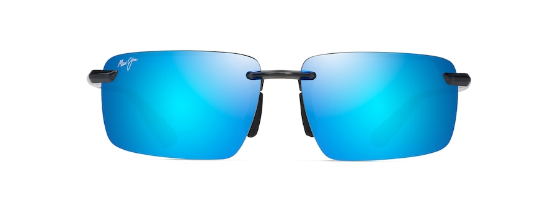
Brand | MAUI JIM
Model Name | LAULIMA
Price | RS 2499
PRODUCT DETAILS

